Daily Treasury Outlook
14 November 2025

Highlights
Global: US equities closed lower with the broad indices of S&P500, Dow, and Nasdaq declining between 1.7% and 2.3% (S&P500: -1.7%; Dow: -1.7%; NASDAQ: -2.3%). The US government shutdown officially ended on 13 November after President Donald Trump signed the funding bill to reopen the federal government. The bill will fund the government through the end of January 2026. The prolonged shutdown is expected to create gaps in economic data, with White House National Economic Council Director Kevin Hassett stating that the jobless rate will not be reported in the October labour market report. This could pose challenges for Fed officials seeking to accurately assess the economy’s health ahead of their December meeting. According to the CME FedWatch Tool, markets last priced in ~51% probability of a 25bp cut on 10 December. In the UK, the preliminary 3Q25 GDP growth came in softer than expected at 0.1% QoQ, down from 0.3% in 2Q25. On a YoY basis, economic growth eased to 1.3% YoY versus 1.4% in 2Q25. The 3Q25 expansion “mainly driven by increases in gross fixed capital formation, household consumption, net trade, and government consumption. These offset a large negative contribution from gross capital formation: other, which reflects lower valuables and inventories compared with Quarter 2 2025.” The GDP release precedes the UK government’s Autumn Budget on 26 November. Fiscal consolidation, include tax hikes, are expected and may further weigh on growth. This could potentially support the case for some further monetary easing at the BoE’s final meeting of the year in mid-December. Responding to the Preliminary 3Q25 growth data, Finance Minister Rachel Reeves stated that she will “take the fair decisions to build a strong economy that helps us to continue to cut waiting lists, cut the national debt and cut the cost of living.”

Market Watch: Data on tap today includes China retail sales, industrial production, and residential property sales. Malaysia will also release its 3Q25 GDP growth data. Consensus and our house view is for the growth to remain broadly stable at 5.2%, similar to its advance release. Later in the day, Hong Kong and the eurozone are also scheduled to report its GDP figures. The eurozone will also report its trade balance and employment figures.

Commodities: Crude oil benchmarks rebounded on Thursday, with WTI and Brent edging marginally higher by 0.3% and 0.5%, respectively, to USD58.7/bbl and USD63.0/bbl. Nonetheless, gains were limited after a stronger-than-expected buildup in US crude inventories. According to the Energy Information Administration (EIA), US crude oil inventories rose by 6.4mn bbls (consensus: +0.9mn bbls), reaching 427.6mn bbls for the week ending 7 November.

Major Markets

ID: Australia and Indonesia have agreed on a new security treaty that commits both nations to consult each other if either faces a threat, marking a significant expansion of earlier agreements. Australian PM Anthony Albanese described the treaty as a continuation of security cooperation dating back three decades, with provisions for regular security dialogue between leaders. Indonesian President Prabowo Subianto emphasised that the treaty reflects a commitment to closer defence and security collaboration. Australian Foreign Minister Penny Wong stated that the treaty, expected to be signed next year, is modelled on a 1995 bilateral security agreement that was later withdrawn after tensions over East Timor. Relations, however, have since improved under Albanese's government.

MY: The Ministry of Investment, Trade and Industry (MITI) announced that Malaysia and China will exchange trade certificates electronically from January 2026, to streamline and augment customs operations. The certificate of origin, is used in international trade to certify the origin country of a product being exported and helps to determine tariffs and compliance with local laws. MITI will sign the agreement with China's General Administration of Customs this month. This will allow the digital exchange of the documents under the Asean-China Free Trade Area and the Regional Comprehensive Economic Partnership, as reported by The Edge. According to MITI, the collaboration aims to improve the transparency of origin verification and enhance Malaysia’s competitiveness among China’s key trading partners.

PH: Insurance coverage in the Philippines expanded significantly by end-September, with total premiums rising 13.2% YoY to PHP372bn, up from PHP328.6bn in the same period last year. The growth was broad-based, with life insurance increasing by 13.8% to PHP299.5bn. Meanwhile, non-life insurance and mutual benefit associations rose by 13.1% and 2.9%, respectively, to PHP60.1bn and PH12.6bn. The insurance industry's total assets rose 4.7% to PHP2.6trn, alongside higher invested assets and net worth at PHP2.3trn and PHP526bn, respectively. Insurance Commissioner Reynaldo Regaldo said that "the accelerating growth in total premiums and other key statistical indicators underscores not only the increasing trust and recognition of the vital role insurance plays in economic resilience, but also the stronger awareness among Filipinos on the value of financial protection."

ESG

SG: The MAS has published key insights from the Transition Credits Coalition (TRACTION)’s final report and published a statement of support for high-integrity energy transition credits to drive power sector decarbonisation. These initiatives aim to advance the development and application of energy transition credits as a credible financing mechanism to accelerate the coal to clean transition in Asia. The next phase will focus on translating TRACTION’s foundational work into concrete projects and transactions, focusing on integrity, transaction scalability and demand-building. The proceeds from transition credits can bridge cost gaps, especially where renewable plants and battery storage are more expensive than fossil fuel or coal-based local utility tariffs.

Credit Market Updates

Market Commentary: The SGD SORA OIS curve traded lower yesterday with shorter tenors trading 2-3bps lower while belly tenors traded 1-2bps lower and 10Y traded 1bps lower. As per Bloomberg, a Chinese court approved a creditor’s request for the bankruptcy of Evergrande New Energy Vehicle (Tianjin) Co., an indirect wholly owned subsidiary of China Evergrande New Energy Vehicle Group. The unit has a registered capital of RMB4.1bn and holds a manufacturing base for smart-mobility vehicles, where production has been suspended since January 2024. In other news on earnings, JD.com posted a 15% revenue increase, beating expectations, driven by government consumer subsidies and expansion into areas like meal delivery. Quarterly sales reached RMB299.1bn, above the average analysts’ forecast of RMB294.4bn, lifting shares over 3% in U.S. pre-market trading. The company is pushing globally with a stake in Germany’s Ceconomy AG, though talks to acquire J Sainsbury’s Argos unit ended in September. Lastly in ratings, Fitch has upgraded Hubei Science & Technology Investment Group Co Ltd Long-term foreign and local currency issuer default rating to BBB+ from BBB with stable outlook. Meanwhile, S&P upgraded Shanghai Electric Group Co Ltd long-term rating to BBB+ from BBB with stable outlook. Bloomberg Asia USD Investment Grade spreads tightened by 1bps to 59bps and Bloomberg Asia USD High Yield spreads tightened by 4bps to 348bps respectively. (Bloomberg, OCBC)

New issues:
There were two notable issuances in the Asiadollar market yesterday.
- Uzauto Motors AJ priced a USD350mn 5Y Fixed Bond at T+367.4bps (par to yield 7.375%)
- China Resources Land Ltd priced a USD300mn 3Y Green Fixed Bond at T+68bps (reoffer price 99.568 to yield 4.28%).

There was one notable issuance in the Singdollar market yesterday.
- Mapletreelog Treasury Company Pte Ltd (guarantor: Mapletree Logistics Trust) priced a SGD75mn 10Y Fixed Bond at 2.40%.

Mandates:
- There were no notable mandates yesterday.

Economic Calendar
Source: Bloomberg
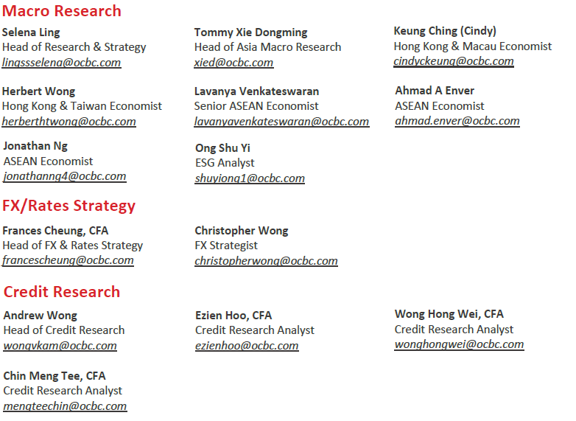

This report is solely for information purposes and general circulation only and may not be published, circulated, reproduced or distributed in whole or in part to any other person without our prior written consent. This report should not be construed as an offer or solicitation for the subscription, purchase or sale of the securities/instruments mentioned herein or to participate in any particular trading or investment strategy. Any forecast on the economy, stock market, bond market and economic trends of the markets provided is not necessarily indicative of the future or likely performance of the securities/instruments. Whilst the information contained herein has been compiled from sources believed to be reliable and we have taken all reasonable care to ensure that the information contained in this report is not untrue or misleading at the time of publication, we cannot guarantee and we make no representation as to its accuracy or completeness, and you should not act on it without first independently verifying its contents. The securities/instruments mentioned in this report may not be suitable for investment by all investors. Any opinion or estimate contained in this report is subject to change without notice. We have not given any consideration to and we have not made any investigation of the investment objectives, financial situation or particular needs of the recipient or any class of persons, and accordingly, no warranty whatsoever is given and no liability whatsoever is accepted for any loss arising whether directly or indirectly as a result of the recipient or any class of persons acting on such information or opinion or estimate. This report may cover a wide range of topics and is not intended to be a comprehensive study or to provide any recommendation or advice on personal investing or financial planning. Accordingly, it should not be relied on or treated as a substitute for specific advice concerning individual situations. Please seek advice from a financial adviser regarding the suitability of any investment product taking into account your specific investment objectives, financial situation or particular needs before you make a commitment to purchase the investment product. In the event that you choose not to seek advice from a financial adviser, you should consider whether the investment product mentioned herein is suitable for you. Oversea-Chinese Banking Corporation Limited (“OCBC Bank”), Bank of Singapore Limited (“BOS”), OCBC Investment Research Private Limited (“OIR”), OCBC Securities Private Limited (“OSPL”) and their respective related companies, their respective directors and/or employees (collectively “Related Persons”) may or might have in the future, interests in the investment products or the issuers mentioned herein. Such interests include effecting transactions in such investment products, and providing broking, investment banking and other financial or securities related services to such issuers as well as other parties generally. OCBC Bank and its Related Persons may also be related to, and receive fees from, providers of such investment products. There may be conflicts of interest between OCBC Bank, BOS, OIR, OSPL or other members of the OCBC Group and any of the persons or entities mentioned in this report of which OCBC Bank and its analyst(s) are not aware due to OCBC Bank’s Chinese Wall arrangement. This report is intended for your sole use and information. By accepting this report, you agree that you shall not share, communicate, distribute, deliver a copy of or otherwise disclose in any way all or any part of this report or any information contained herein (such report, part thereof and information, “Relevant Materials”) to any person or entity (including, without limitation, any overseas office, affiliate, parent entity, subsidiary entity or related entity) (any such person or entity, a “Relevant Entity”) in breach of any law, rule, regulation, guidance or similar. In particular, you agree not to share, communicate, distribute, deliver or otherwise disclose any Relevant Materials to any Relevant Entity that is subject to the Markets in Financial Instruments Directive (2014/65/EU) (“MiFID”) and the EU’s Markets in Financial Instruments Regulation (600/2014) (“MiFIR”) (together referred to as “MiFID II”), or any part thereof, as implemented in any jurisdiction. No member of the OCBC Group shall be liable or responsible for the compliance by you or any Relevant Entity with any law, rule, regulation, guidance or similar (including, without limitation, MiFID II, as implemented in any jurisdiction).

The information provided herein may contain projections or other forward looking statements regarding future events or future performance of countries, assets, markets or companies. Actual events or results may differ materially. Past performance figures are not necessarily indicative of future or likely performance.

Privileged / confidential information may be contained in this report. If you are not the addressee indicated in the message enclosing the report (or responsible for delivery of the message to such person), you may not copy or deliver the message and/or report to anyone. Opinions, conclusions and other information in this document that do not relate to the official business of OCBC Bank, BOS, OIR, OSPL and their respective connected and associated corporations shall be understood as neither given nor endorsed.

Co.Reg.no.: 193200032W

